Warning Alert Arduino System

Produced by AKF Systems

Purpose:

The idea behind this product is to accurately indicate when medications are below a certain amount and warn the user when the amounts are below an indicated level. This will give medical professionals a worry free device that will alert them when it is the appropriate time to refill their medicinal dispensing units.

Device:

Using the amazing power of the Arduino system, this warning alert system is interconnected. Therefore, if one part of the system does not work, it will not work at all! Arduino has the ability to work with the program, MATLAB, in order to successfully monitor according to the users parameters.

Five sensors are used in this medical device: a touch sensor, a tracking sensor, a buzzer, a push button, and an LED light.

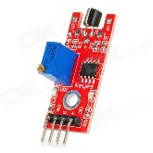 Touch Sensor 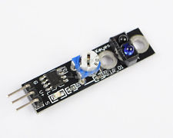Track Sensor 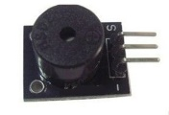Buzzer Sensor

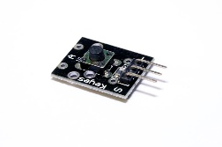 Push Sensor 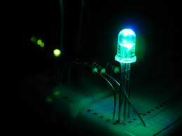 Green LED Light

Functionality:

This easy to use product, will not only monitor when the medications in your dispensing are low but it will also give a warning when this occurs. Thus giving the medical professional a worry free environment and the ability to focus on the many other responsibilities they may have. With low maintenance and easy to use interface, this device is the ideal product for all medical professional who do not have to time to deal with inconsistence readings or complicated programs.

HOW IT WORKS!



Green Means go! Once the device is fully functional, the green LED light will indicate the device is ready and will appear!



With the ease of a push, the medications will slowly dispense into the patient and therapy can begin.

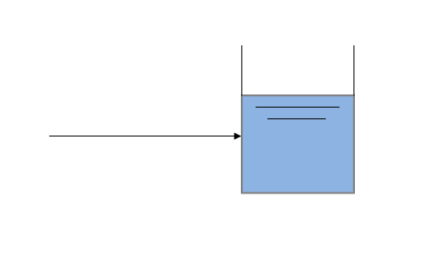 

Once the medication is below the desired amount, a track sensor will detect that the fluid is below warning levels and an alarm buzzer will ring.



As soon as the medical professional is aware of the alarm, a slight push of a button will turn off the device.

